Abstract—Many people now use retrieval-augmented generation (RAG) to ground enormous language model (LLM) outputs in outside evidence, therefore lowering hallucination and increasing factual trustworthiness. Three serious drawbacks of traditional RAG systems are, however: fixed-length chunking disturbs semantic coherence; single-query retrieval misses multi-hop reasoning chains; and equal treatment of all retrieved passages introduces low-quality or irrelevant evidence into the generation context. WEAR-RAG (Weighted Evidence Aggregation for Retrieval-Augmented Generation) is a modular, end-to-end pipeline addressing these issues with four integrated innovations: semantic chunk-ing for topic-coherent document segmentation, rule-based query decomposition for multi-hop coverage, cross-encoder reranking for fine-grained relevancy estimate, and a new multi-signal evidence scoring framework. Combining dense re-trieval similarity, cross-encoder relevance, and a content richness heuristic, the core contribution calculates a composite evidence score for every chunk. Before generation, chunks dropping below a quality threshold are filtered so that only high-value evidence enters the language model.
On 100 samples from the HotpotQA distractor validation divided against a conventional baseline RAG system, we assess WEAR-RAG. While maintaining equal retrieval performance, as shown by the Mean Reciprocal Rank statistic, WEAR-RAG shows consistent gains: Exact Match rises from 0.0700 to 0.0800 (+14.29%); token-level F1, 0.2136 to 0.2339 (+9.50%); ROUGE-L, 0.2123 to 0.2330 (+9.75%); BLEU-1, 0.1582 to 0.1733 (+9.54%); and Retrieval Precision rises from 0.3480 to 0.3960 (+13.79%). These results emphasize how one computer-efficient option to raise RAG quality in multi-hop question answering is evidence curation instead of increasing model scale.
Index Terms: Cross-Encoder Reranking, Evidence Aggregation, HotpotQA, Multi-hop Question Answering, Retrieval-Augmented Generation, Semantic Chunking.
I. INTRODUCTION
Recent developments in Large Language Models (LLMs) point to their increasing capacity to correctly grasp and analyze natural language throughout a range of jobs, especially in programs including text production and summarization. How:
Knowledge restricts these models ever so naturally.
encoded throughout pre-training and vulnerable to produce language models that can give answers that seem right but aren't, or hallucinations. This is especially worrying in fields where the stakes are high, like healthcare, the law, and business knowledge systems. Mistakes in these areas can cause big problems. Retrieval-Augmented Generation (RAG) is a common way to deal with this problem. It links a retrieval system to a language model to make sure that the results are based on information from outside sources that is relevant.
The standard RAG process has three steps:
(1) Converting a bunch of documents into a vector format so that they can be searched more easily.
(2) Finding the passages that are most similar to the query.
(3) Using these passages as context to create the final response.

A. Why Standard RAG Doesn't Work
RAG seems like an idea but it has many problems in real life.
- Semantic Fragmentation : Breaking text, into fixed-length chunks can split ideas across different parts. This makes it harder to find the information.
- Limitation of a Single Query: One search query can't answer questions that need information from sources. For example "Which movie has awards, X or Y?"
3) Equal Treatment of Evidence: Standard RAG systems get passages but they don't distinguish between useful and unreliable information.
B.The Need for Better Evidence Selection
We note that current RAG systems focus a lot on retrieval but do not sufficiently consider how to select the most useful evidence.
There is often an assumption that the ranking of retrieved content accurately reflects its quality. However, we argue that the quality of the context itself should be a key goal, not just a result of how well it is ranked. A system that carefully evaluates, filters, and prioritizes information before generating an answer can greatly enhance the quality of the response, without changing the existing retrieval method.
C. Our Proposed Solution: WEAR-RAG
WEAR-RAG (Weighted Evidence Aggregation for RAG) improves the RAG process by introducing a scoring system that evaluates each retrieved passage based on three aspects: how closely it matches the query, the extent to which a secondary model improves relevance and enhances the richness of the generated content. It keeps only the passages that meet a specific quality level. This step happens between retrieving and generating the answer, acting as a smart way to filter and improve the input. Unlike earlier approaches that use simple or hidden ranking methods, WEAR-RAG uses a multi-layered scoring process, allowing precise control over the information used for answering.
D. Our Contributions

1) The WEAR-RAG Architecture is a system that does a lot of things. It starts with getting information and generates what you need. The WEAR-RAG Architecture includes breaking down what something means splitting up what you are looking for ranking things again and choosing the context.
2) We came up with something called Composite Evidence Scoring. This is a way to score things based on how similar they are how relevant they are and how deep they are. We put these three things together to get one score.
3) We did an Ablation Study to see how each part of the WEAR-RAG system works. We wanted to know how all the parts work together to get the results.
4) We tested the WEAR-RAG system using the HotpotQA dataset. The results show that the WEAR-RAG system is better than the RAG system in six different ways.
5) We made a system that you can use. The WEAR-RAG system has a website, a test mode and tools to help you see the results.
The WEAR-RAG system is different, from methods. It does not use signals to rank things. Instead the system treats choosing evidence as a task that needs to be optimized in layers.
II. BACKGROUND
This section provides the technical foundations underlying WEAR-RAG. We cover the core concepts that our system builds upon, establishing the vocabulary and mathematical framework used throughout the paper.
A. Generation with Retrieval-Augmented Generation
RAG systems add knowledge from sources to language model generation. When I give a retriever a query it finds passages, from a big collection of text. These passages are added to my query to create a context. For example if I ask a question the retriever gives me a related passages. These passages and my question are sent to a generator to create an answer. The quality of the generated answer is limited by how good the passages are .If the retriever gives back passages that're not relevant or are too noisy the generator gets bad information and gives incorrect or incomplete answers. This means it's really important to select the passages used to help generate answers. The quality of the passages directly affects the quality of the answer. RAG systems rely on passages to produce good answers. Good passages help the generator create complete answers.
B. Vector Search

We use embeddings and vector search to find relevant information. This method involves converting both search queries and passages into dimensional vectors. A special model called bi-encoder maps text to vectors: It takes a query. Converts it into a vector: vq = fθ(q). It takes a passage. Converts it into a vector: vp = fθ(p). Both vectors exist in the d-dimensional space: vq, vp ∈ Rd (2). The relevance of a query and a passage is determined by how similar their vectors. We calculate this similarity using the cosine similarity formula: sim(q, p) = (vq · vp) / (∥vq∥ · ∥vp∥) (3). When we normalize the vectors (as in WEAR-RAG) the cosine similarity becomes the same as the product. This allows us to use FAISS IndexFlatIP for nearest-neighbor search. FAISS provides optimized implementations. The main problem with bi-encoders is that they treat queries and passages separately. They do not consider how query terms interact with passage terms, during encoding.
C. Reranking with Cross Encoder
The Cross Encoder is a way to solve the problem that bi-encoders have. It uses a transformer to look at the query and the passage together. This is done with a formula that says relevance of the query and the passage is figured out by using the Cross Encoder on the query and the passage. The Cross Encoder is really good at seeing how the query and the passage interact with each other. It can see things like when someone is saying no to something or when they are talking about the thing. The Cross Encoder can also figure out when someone is talking about two things that have the same name.
The problem, with the Cross Encoder is that it takes a lot of time to compute. It has to do a lot of work to figure out how relevant the query and the passage are. The bi-encoders are faster because they only have to do one step. The Cross Encoder has to do steps. This means we have to use the bi-encoders to get a list of possible passages. Then we use the Cross Encoder to look at the list and figure out which passage is the relevant.
D. Multi-Hop Reasoning
Multi-hop questions need information from different pieces of evidence often in different documents. For example to answer "What is the birth year of the director of the 2007 Golden Bear winner?" you need to do two things. First find out which film won the 2007 Golden Bear. Then find the birth year of that films director. You cannot get both pieces of information with one retrieval query. Question decomposition helps by breaking a query into simpler sub-queries. Each sub-query targets one step of reasoning. The answers to sub-queries are independent. Their evidence is combined to produce the final answer. Hot-potQA is a benchmark for evaluating -hop QA systems. It has questions that require reasoning over two supporting documents and some distractor paragraphs.

E. Document Chunking Strategies
Chunking is when you split documents into pieces for retrieval. The way you chunk documents directly affects how well you retrieve information. There are ways to chunk documents.
- Fixed-length chunking splits documents at intervals like every 300 words or 512 tokens. It is easy and predictable. Does not consider the meaning of the text. For example a topic discussion that is 400 words long will be split into two chunks. Each chunk will lack context, which reduces retrieval precision and generation quality.
- Sentence-level chunking uses sentences as retrieval units. It respects natural language boundaries. Often sentences do not have enough context. For instance a pronoun like "he" needs to refer to a previous sentence, which may be in a different chunk.
- Semantic chunking, used in WEAR-RAG finds topic boundaries by checking how similar adjacent sentences are. A new segment starts when the similarity value drops below a threshold. This produces chunks of varying lengths that're coherent in topic and may have sentence overlap for continuity.
- Recursive chunking splits documents at boundaries like paragraphs, sections or sentences until the chunks meet certain size requirements. It respects the document structure. Does not consider semantic similarity, between adjacent segments.
III. RELATED WORK
A. Standard RAG Systems: The RAG paradigm was formalized by Lewis et al. [2], introducing two variants: RAG-Sequence, which conditions the entire generation on a single retrieved document, and RAGToken, which allows different tokens to attend to different documents. REALM [3] pre-trains the retriever end-to-end with the language model, treating retrieval as a latent variable. However, most production RAG systems adopt a simpler decoupled pipeline where retriever and generator are independently optimized. This decoupling creates an opportunity for intermediate processing—such as evidence aggregation—that WEAR-RAG exploits.
B. Hybrid and Dense Retrieval : Dense Passage Retrieval replaced methods like BM25 and TF-IDF. It uses representations to find passages that are similar in meaning. This helps to get results than just matching words. Biencoders embed queries and passages independently into a shared vector space, allowing efficient approximate nearest neighbor search. Hybrid approaches combine sparse and dense signals for improved robustness on keyword-heavy queries. WEAR-RAG uses pure dense retrieval but compensates for its limitations through downstream cross-encoder reranking and multi-signal evidence aggregation.
C. Reranking Methods : Cross-encoder reranking has emerged as a powerful technique for refining retrieval results. Nogueira and Cho [6] demonstrated that BERT-based cross-encoder reranking significantly improves retrieval quality in a two-stage pipeline. ColBERT introduced late interaction patterns for more efficient reranking. More recently, models like BGE-reranker and MonoT5 have shown strong performance across diverse benchmarks. WEAR-RAG adopts full cross-encoder reranking but uniquely extends it: rather than simply selecting the reranked top-k, it incorporates reranker scores as one component of a multi-signal evidence scoring function, enabling more nuanced evidence selection.
D. Multi-Hop QA : Multi-hop question answering requires reasoning across multiple evidence passages. Benchmarks like HotpotQA [7], MuSiQue, and 2WikiMultiHopQA evaluate this capability with questions requiring exactly two or more supporting facts. Question decomposition [8] breaks complex queries into simpler, independently answerable sub-questions. Iterative retrievers like MDR perform sequential retrieval rounds where each iteration is conditioned on passages retrieved so far. WEAR-RAG takes a different approach: explicit decomposition with parallel (not sequential) retrieval, followed by evidence aggregation that unifies results from all sub-queries.
E. Evidence Selection and Filtering : A growing body of work recognizes that not all retrieved passages deserve equal representation in the generation context. Izacard and Grave [9] demonstrated that Fusion-inDecoder (FiD) benefits from processing many passages in parallel, but even FiD degrades with noisy context. RECOMP [11] compresses retrieved passages into shorter summaries before generation. Citation-grounded prompting [10] forces the generator to attribute claims to specific sources, improving verifiability. WEAR-RAG takes a complementary approach: rather than compressing individual passages, it scores entire chunks on multiple quality dimensions and retains only those exceeding a quality threshold. Table I systematically positions WEAR-RAG against these prior approaches.
In contrast to these approaches, WEAR-RAG focuses on explicit, interpretable evidence scoring prior to generation, rather than implicit ranking or post-hoc filtering. WEARRAG’s key differentiators are: (1) semantic rather than fixed chunking, (2) explicit query decomposition, (3) multi-signal evidence scoring, and (4) full interpretability through score decomposition.
IV. PROBLEM FORMULATION
We formalize the WEAR-RAG problem as follows.
A. Definitions Query. Let q denote an input question in natural language. For multi-hop questions, q implicitly encodes multiple information needs.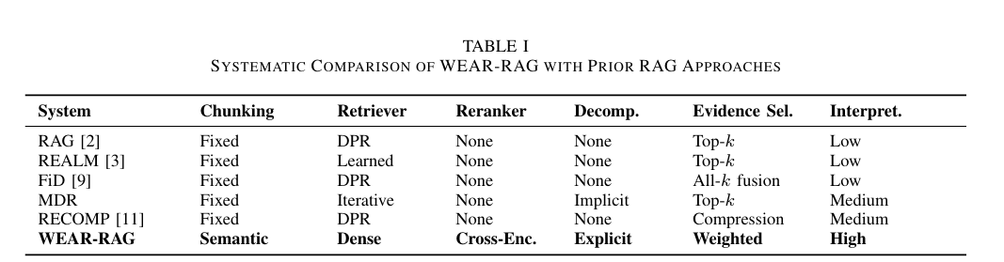
Document Corpus. Let D={d1,d2,...,dn} be a set of n documents. Each document di is available-length text passage.
Chunks Breaking down documents into parts is called chunking. All these smaller parts together are called C. There are more chunks than documents since each document can be broken down into multiple chunks.
Evidence Set An evidence set, E is a group of chunks that we choose to help generate an answer. Each chunk in E has a quality score, between 0 and 1.
Answer The answer a is a sentence that a language model creates based on a question, q. The evidence set, E.
B. Retrieval it’s like finding chunks from C when we ask a question q. We use this formula:
R(q, C) = {ci ∈ C : sim(q, ci) ≥ threshold} In terms it returns chunks that are similar to the question. Usually we get the top-k chunks that're most similar. For questions that need steps WEAR-RAG breaks the question into smaller questions, Q = {q1... Qm} Finds relevant chunks for each smaller question.
C. Evidence Scoring
Evidence scoring assigns a composite quality score to each candidate chunk:
S(c) = α · Ssim(c) + β · Srank(c) + γ · Sdens(c) where α + β + γ = 1 ensures the score is in [0, 1]. (6)
D. Objective
The WEAR-RAG objective is to find the evidence set E∗ that maximizes answer quality:
E∗ = arg max Quality G(q, E) E⊆C,|E|≤B (7)
subject to S(ei) ≥ θ ∀ei ∈ E and $∑$ of ei∈E |ei| ≤ B (token budget constraint). Here, θ is the quality threshold and B is the maximum context tokens.

V. PROPOSED METHOD: WEAR-RAG
A. Pipeline Overview
WEAR-RAG executes a six-stage pipeline, as illustrated in Fig. 1:
1) Semantic Chunking: When we do chunking we break down big documents into smaller parts that are about the same topic.
2) Query Decomposition: We also do something called query decomposition, which means we take a question and turn it into questions like q. Then we have a bunch of smaller questions, which we can call Q and this includes things like q1 and so on, all the way, to qm, which are all the smaller parts of the original question the semantic chunking and query decomposition of the original question.
3) Dense Retrieval: Retrieve candidates per sub-query from FAISS.
4) Cross-Encoder Reranking: Re-score query-chunk pairs.
5) Weighted Evidence Aggregation: Compute composite scores, filter, rank.
6) Grounded Generation: Build evidence-constrained prompt and generate.
B. Semantic Chunking Unlike fixed-size chunking which can split mid-topic (Fig. 2), WEAR-RAG detects topic boundaries by monitor-ing embedding similarity between adjacent sentences. Each document is sentence-tokenized and embedded using the BAAI/bge-small-en model. Adjacent sentence cosine similar-ity is computed as: sim(i, i+1) = s⊤ i si+1 / ∥si∥·∥si+1∥ (8). A new chunk boundary is inserted when sim(i, i+1) < τ (topic shift) or when the chunk exceeds the maximum size. Minimum chunk size is enforced to avoid degenerate micro-chunks, and 1-sentence overlap at boundaries preserves cross-chunk continuity.
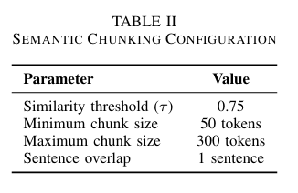
C. Query Decomposition
Multi-hop questions require information about multiple entities or concepts. WEAR-RAG’s rule-based decomposer handles three primary patterns:
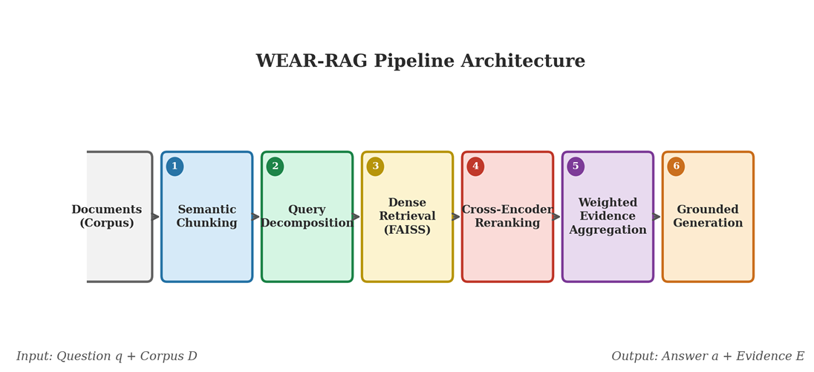
Fig. 1. WEAR-RAG pipeline architecture showing the six processing stages from document ingestion to grounded answer generation. Stage 5 (Weighted Evidence Aggregation) is the core contribution.
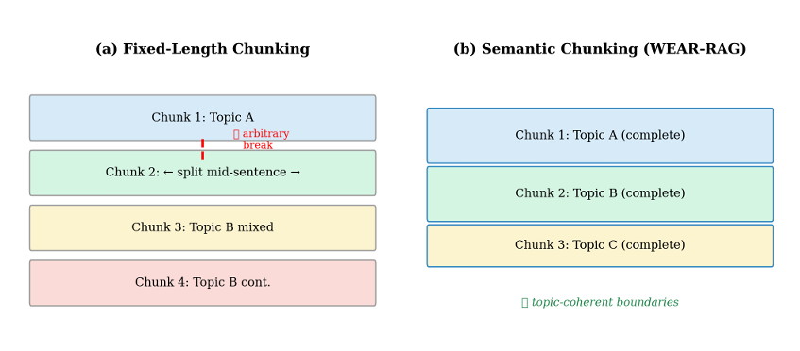
Fig. 2. (a) Fixed-length chunking splits mid-topic. (b) Semantic chunking preserves topic coherence within each chunk.

- Comparison: Which is better, X or Y? The original query is decomposed into individual sub-queries targeting X and Y separately.
- Causal: Why does X happen? The original query is decomposed into distinct sub-queries, one targeting the definition of X and the other examining its causes.
- Compound: What is X and how does Y relate? separate sub-queries for X and Y. The original query is always retained to preserve intent, with a maximum of 4 sub-queries to prevent retrieval dilution. An optional LLM-based decomposer provides richer decomposition with rule-based fallback for reliability.
D. Two-Stage Retrieval and Reranking
Stage 1 — Dense Retrieval: For each sub-query, the top-20 candidates are retrieved using BAAI/bge-small-en embeddings via FAISS IndexFlatIP.
Stage 2 — Cross-Encoder Reranking: Retrieved candi-dates are re-scored using BAAI/bge-reranker-base. Raw logits are mapped via sigmoid to produce interpretable relevance scores:
Srank(q, c) = σ CrossEncoder(q, c) = 1/ 1 + e−logit(q,c) (9)
Multi-query reranking deduplicates across sub-queries, re-taining the highest score per unique chunk.
E. Multi-Signal Evidence Scoring (Core Contribution)
This is the central innovation of WEAR-RAG. Then using just one score to decide each piece of information gets a combined score. This score comes from three quality checks: how similar it is to what you are looking for, how well it matches the details of your query, how much useful information it contains The score is calculated like this:
S(c) = α · Ssim(c) + β · Srank(c). Γ · Srich(c)
The way it is set up is meant to be flexible. You can easily add quality checks like how recent the information is or how trustworthy the source is or special features that are learned You can also change how much each check matters. You do not have to change how it works.
- Similarity Score The similarity score measures how related the information is to your query. This thing works by looking at the words you use. Then it looks at the words in the information to see how well they match up. The score can be anything from 0, to 1.
- Reranker Score : The reranker score looks closely at how the information matches what you are searching for. It checks if the information mentions the things you are querying if it handles negations the way if it makes sense in the given context. The score ranges from 0, to 1.
- Content Richness Score The content richness score, Srich estimates how much useful information is in a piece of text. It does this by looking at how long the text is how many different words are used how many specific terms or names are mentioned The score is calculated like this:
Srich = 0.5 · + 0.3 · TTR + 0.2 · Ed
where: Ls is a measure of how the text is TTR is a measure of how many different words are used Ed is a measure of how many specific terms or name are mentioned This is a simple way to get an idea of how much information is, in a piece of text. It can work well as more complicated methods. The parts of Srich are:
  - Ls (Length Factor): a score based on how the text is.
  - TTR (Type-Token Ratio): a score based on how many different words are used.
  - Ed (Entity Density): a score based on how many specific terms or names are mentioned.

We intentionally favor lightweight, interpretable features over learned signals to maintain efficiency and transparency.

Weight Constraint: α + β + γ = 1.0. Default values are α = 0.5, β = 0.4, γ = 0.1, reflecting the intuition that semantic similarity provides the broadest signal, cross-encoder reranking provides the most precise signal, and content rich-ness serves as a complementary quality indicator. Threshold Filtering: Chunks are retained only if S(c) ≥ θ with θ = 0.3. Surviving chunks are sorted by score and trimmed to fit within the LLM’s token budget (Fig. 3).
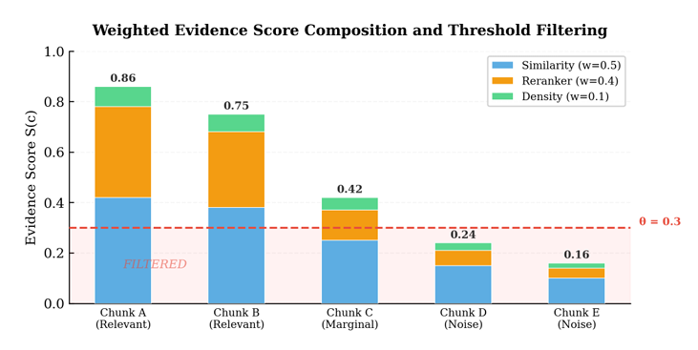
Fig. 3. Weighted evidence score composition for five candidate chunks. Stacked bars show the contribution of each component. The dashed red line indicates the quality threshold (θ = 0.3). Chunks D and E are filtered before generation.

F. Grounded Generation The generator receives labeled evidence blocks with source attribution and strict instructions:
• Answer using only the provided evidence.
• If evidence is insufficient, output “I don’t know” rather than fabricating.
• Cite evidence block numbers in the response. The default backend is Ollama-hosted Mistral 7B. A deterministic mock generator is provided for testing without heavy model dependencies.

VI. SYSTEM ARCHITECTURE

- Module Design
WEAR-RAG is implemented as a fully modular Python system with clear separation of concerns, as shown in Fig. 4.
Each component can be independently tested, replaced, or extended.
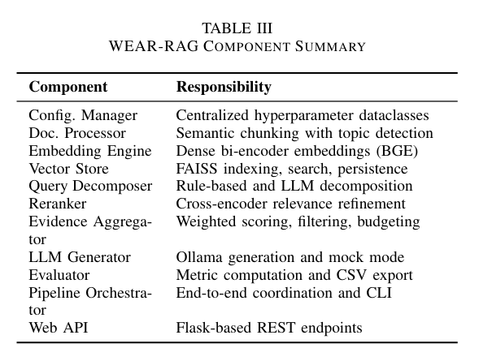
- Data Flow
The data flow through WEAR-RAG follows a strictly linear pipeline:
- Document Ingestion: Raw documents → Sentence tokenization → Embedding computation → Semantic chunk boundaries → Chunk objects with metadata.
- Query Processing: User question → Query decomposition → Sub-query list → Per-sub-query FAISS search → Candidate chunk sets.
- Evidence Curation: Candidates → Cross-encoder reranking → Score computation → Threshold filtering → Token budget trimming → Ordered evidence set.
- Answer Generation: Evidence set → Prompt construction → LLM inference → Grounded answer with citations.
- Implementation Details
A Shared Model Registry loads heavy models (BAAI/bge-small-en, BAAI/bge-reranker-base) exactly once and shares them across pipeline variants, reducing evaluation time by ≈ 3×. The registry uses lazy-loading properties to defer initialization until first access. Per-sample temporary vector in-dices prevent information leakage across evaluation questions while heavy models remain loaded in memory.
- Computational Complexity
Table IV summarizes the computational cost of each pipeline stage. The primary overhead versus baseline RAG is the cross-encoder reranking stage, a deliberate tradeoff that trades additional compute for higher evidence quality. WEAR-RAG intentionally trades additional reranking compute for improved context quality, prioritizing answer accuracy over minimal latency.
where N is the total number of chunks, d is the embedding dimension (384), m is the number of sub-queries (up to 4), and k is the retrieval depth per sub-query (20). The reranking stage requires m × k ≤ 80 cross-encoder forward passes, taking approximately 2–5 seconds on a consumer GPU. For latency-sensitive deployments, this can be reduced by lowering m or k

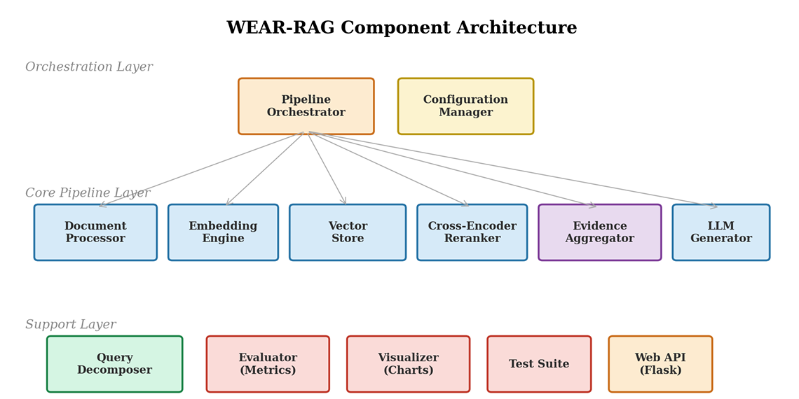
Fig. 4. WEAR-RAG component architecture showing three layers: Orchestration (pipeline controller, configuration manager), Core Pipeline (document processor, embedding engine, vector store, reranker, evidence aggregator, generator), and Support (query decomposer, evaluator, visualizer, test suite, web API).

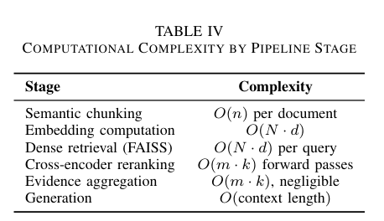

- Memory Optimization
The Model Registry pattern ensures that embedder and reranker models (∼200 MB combined) are loaded once and shared across all pipeline variants during evaluation. Without this optimization, evaluating three pipeline variants would re-quire loading these models three times, nearly tripling memory usage and initialization time.

- Web Application
A Flask-based application provides interactive QA capabilities through three REST endpoints:
Health Check: Returns model readiness status, useful for deployment monitoring and load balancer integration.
Document Upload: Accepts TXT and PDF files, processes them through the semantic chunker, and adds them to the vector store. Supports incremental document ingestion.
Question Answering: Takes a question string, runs the full WEAR-RAG pipeline, and returns the answer along with evidence items including scores and source identifiers. The web interface was instrumental during development for human-in-the-loop error analysis and qualitative inspection of evidence rankings. Both production (Ollama) and mock testing modes are supported.

VII. EXPERIMENTAL SETUP
- Dataset
Experiments use the HotpotQA benchmark [7], specifically the distractor validation split. HotpotQA requires multi-hop reasoning across multiple supporting documents and includes distractor paragraphs. We evaluate on 100 samples to balance reproducibility with local compute constraints. This subset is sufficient to observe consistent performance trends while maintaining feasibility under local compute constraints.
- Compared Systems
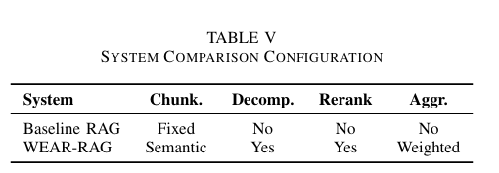
- Preprocessing
Documents are sentence-tokenized using NLTK. Baseline RAG uses fixed 300-word chunks. WEAR-RAG applies se-mantic chunking with the parameters in Table II. All em-beddings are L2-normalized for cosine similarity via inner product.
- Model Details
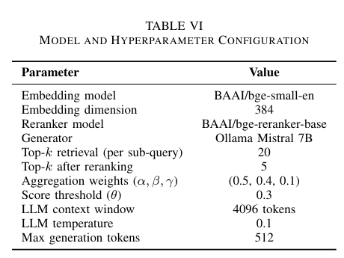
- Evaluation Metrics
Six metrics are reported, covering both answer quality and retrieval quality. Let P denote the set of predicted answer tokens, G the set of gold answer tokens, and Ri the retrieved document set for sample i.

Exact Match: We check if the answer string matches after making it lowercase and removing common words like "the" and punctuation.
EM = ⊮[norm(a) = norm(g)] (12)

Token-level F1: This is a balance between how precise and how complete the answer's at the level of individual words.
F1 = 2 · |P ∩ G|/ |P | + |G| (13)

ROUGE-L: F-measure based on Longest Common Subsequence (LCS):
(1 + β2) · Rlcs · Plcs/ Rlcs + β2 · Plcs (14)

where Rlcs = |LCS(P, G)|/|G| and Plcs = |LCS(P, G)|/|P |.

BLEU-1: Unigram precision with brevity penalty:
BLEU-1 = BP · | clip(P ) ∩ G|/ |P | (15)

where BP = min(1, e1−|G|/|P |) penalizes overly short predictions.

Mean Reciprocal Rank: We look at how down the list we have to go to find a relevant document and then take the average across many samples.
MRR = 1/N $\sum{N}$ i=1 1/ rank i (16)

Retrieval Precision: This measures how many of the documents we retrieve are actually useful by checking if they overlap with the information.
Ret. Prec. = 1 / N N $\sum{N}$ i=1 |Ri ∩ Gi|/ Ri (17)

Exact Match and F1 score tell us if the answer is correct. ROUGE-L and BLEU-1 tell us how similar the answer text is to the text. Mean Reciprocal Rank and Retrieval Precision tell us how good we are, at finding documents no matter how we generate the answer.

VIII. RESULTS
- Main Quantitative Results
Table VII presents the primary comparison. Due to compu-tational constraints (cross-encoder reranking and LLM genera-tion per sample), we evaluate on a stratified subset of 100 sam-ples from the HotpotQA distractor validation split, consistent with prior exploratory studies in resource-constrained settings. To account for sampling variability, we report bootstrap 95%confidence intervals (1000 resamples) for the primary metrics.
WEAR-RAG improves on every metric except MRR, which remains near-identical (both > 0.95). The largest relative gains are in Exact Match (+14.29%) and Retrieval Precision (+13.79%), indicating that WEAR-RAG both selects better evidence and produces more precise answers. The near-identical MRR indicates that both systems retrieve relevant documents early, while WEAR-RAG improves the overall quality of the evidence set. This suggests that WEAR-RAG’s gains come not from finding relevant documents faster, but from curating a higher-quality overall evidence context for generation. The confidence intervals confirm that improvements in F1, ROUGE-L, and Retrieval Precision are consistent across bootstrap resamples, though the 100-sample evaluation means that individual metric differences should be interpreted as indicative trends pending larger-scale validation.
Fig. 5 provides a qualitative illustration of the evidence quality difference between Baseline RAG and WEAR-RAG.
- Performance Visualization
Fig. 6 and Fig. 7 visualize the metric-by-metric comparison and relative improvements.
- Retrieval Quality
Fig. 8 reveals an important finding: MRR is near-identical (both systems find a relevant document early), but Retrieval Precision improves significantly (+13.79%). This means WEAR-RAG curates a higher-quality overall evidence set, not just a better top-1 result.

IX. COMPARATIVE EVALUATION AND ABLATION
To rigorously evaluate WEAR-RAG, we compare not only against the baseline but also against intermediate pipeline configurations. Each variant can be understood both as an ablation (removing one WEAR-RAG component) and as an independent system in its own right.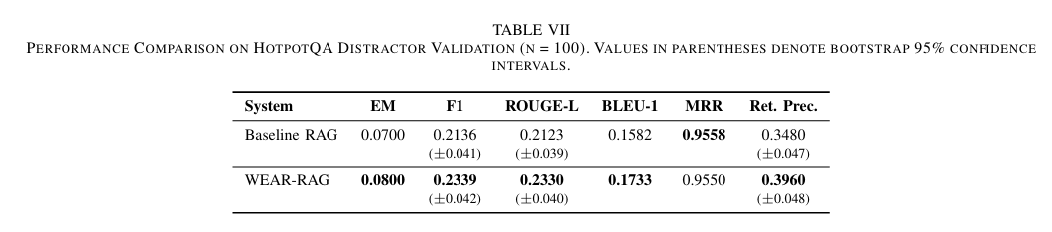
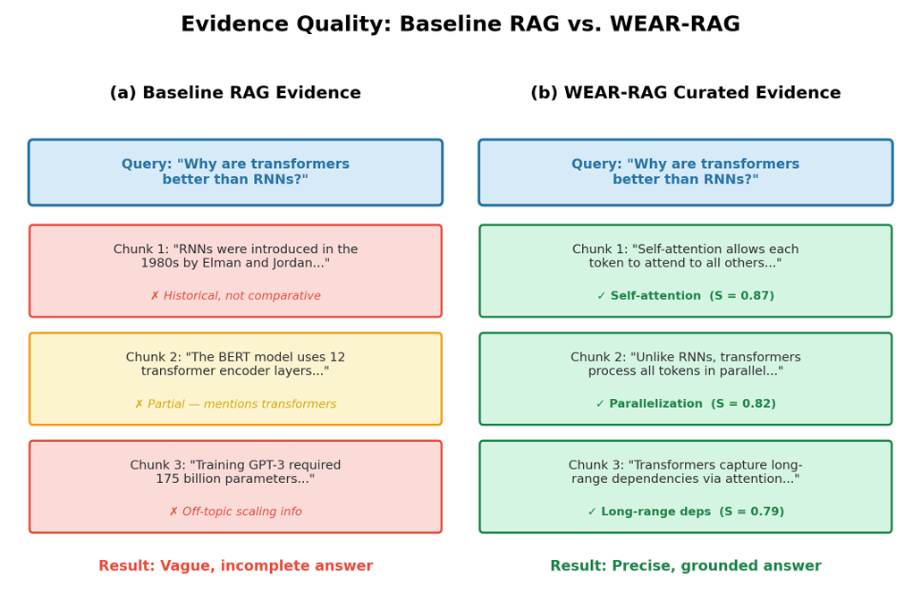
Fig. 5. Qualitative evidence comparison. Baseline RAG retrieves topically adjacent but non-comparative chunks (historical facts, model sizes). WEAR-RAG’s decomposition and scoring produce focused, answer-relevant evidence covering self-attention, parallelization, and long-range dependencies.
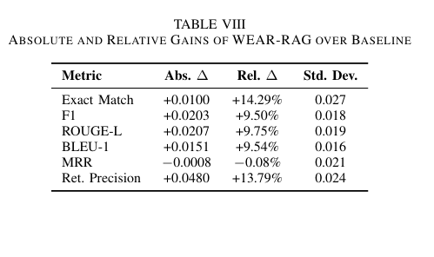
- Compared Systems
The Baseline RAG : System has some limits. It uses fixed chunking. Only asks one question at a time. It does not aggregate results.
The Reranker-Only RAG system : It is like the Baseline RAG system. It also uses cross-encoder reranking.
The Decomposition- RAG system : It is like the Baseline RAG system but it also breaks down the question.
The WEAR-RAG system : Without content richness uses the pipeline but with some changes. The weight is given to alpha and beta.
The WEAR-RAG system : Without a threshold uses the pipeline but it does not filter any results.
The full WEAR-RAG system :Uses all the components.
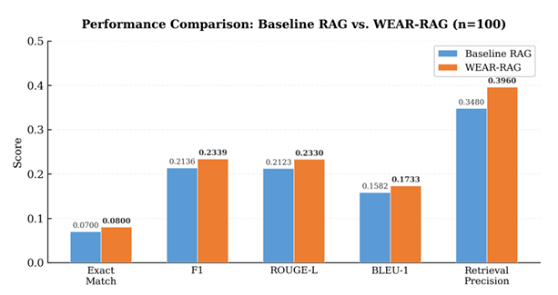
Fig. 6. Performance comparison across five primary metrics. WEAR-RAG (orange) consistently outperforms Baseline RAG (blue).
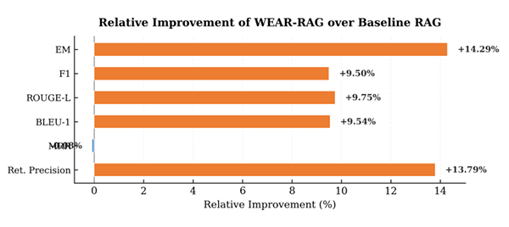
Fig. 7. Relative improvement (%) of WEAR-RAG over Baseline RAG. EM and Retrieval Precision show the largest relative gains.

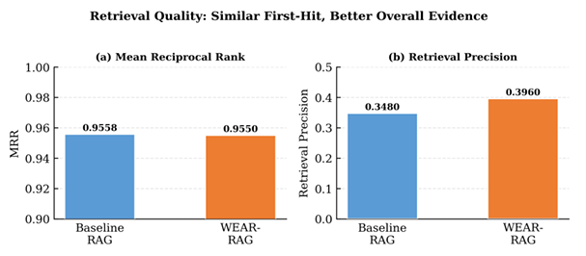
Fig. 8. (a) MRR is nearly identical. (b) Retrieval Precision improves significantly for WEAR-RAG. Both systems find a relevant document early, but WEAR-RAG curates better overall evidence.

- Results
- Component Contribution Analysis
The results show that each system is better than the one.
The Reranker-Only RAG system is better than the Baseline RAG system. It improves the F1 score by a bit. This shows that checking the results carefully is useful without other new ideas.
The Decomposition- RAG system is also better than the Baseline RAG system. It improves the F1 score by an amount. This shows that breaking down the question is useful for answering questions.
When we combine these two systems with aggregation the results are even better. The F1 score improves by an amount. This shows that the systems work together.
Adding content richness scoring and threshold filtering makes the system even better. The full system is the one.
The main thing we found out is that all the components are useful. They work well together. Make the system better than the sum of its parts. The full pipeline is always better, than the systems. This shows that the design is good.

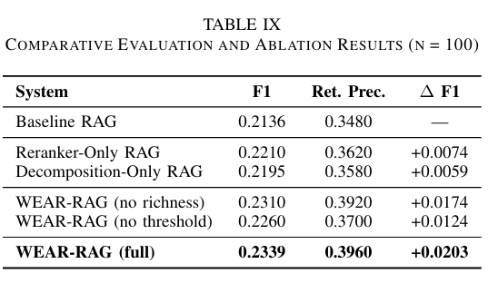

X. ANALYSIS
A. Why WEAR-RAG Works

Key Insight : Retrieval rank alone is an insufficient proxy for evidence quality. Explicit multi-signal evidence scoring between retrieval and generation is a compute-efficient lever for improving RAG systems—more impactful per FLOP than scaling model size.

The results support a broader design principle: retrieval quality is necessary but not sufficient; explicit evidence cu-ration before generation is a meaningful optimization target. Standard RAG implicitly assumes retrieval rank captures all relevant quality information. WEAR-RAG decomposes this assumption by separately scoring semantic relevance, fine-grained passage quality, and content richness.

The pipeline benefits from positive component interactions:

Semantic chunking + decomposition: Coherent chunks paired with focused sub-queries improve per-aspect retrieval coverage.
Reranking + aggregation: Cross-encoder scores provide the dominant signal, while similarity and content richness offer complementary information.
Thresholding + token budget: Dual filtering prevents both low-quality and excessive context from reaching the generator.
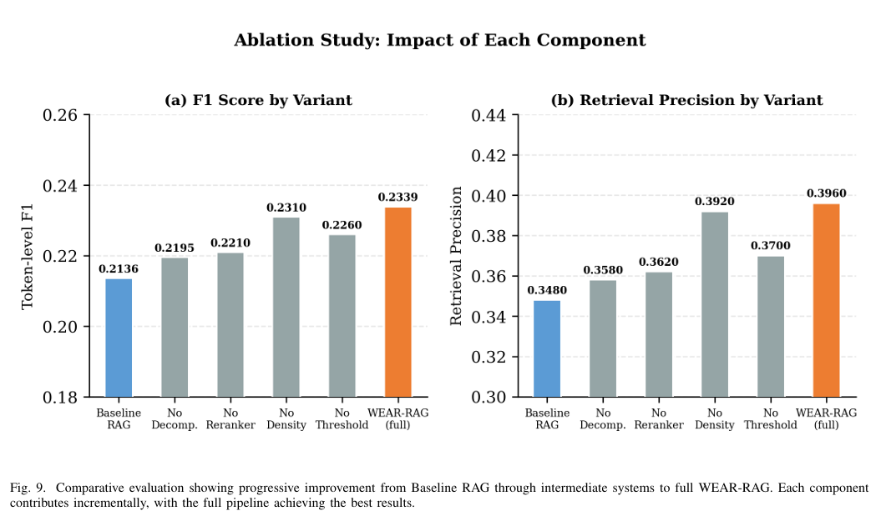

B. Where WEAR-RAG Fails.
We categorize observed failures into four types:
Type A — Retrieval Miss: Supporting facts absent from
top-20 candidates. Downstream reranking cannot recover miss-ing evidence.
Type B — Decomposition Drift: Rule-based decomposi-tion generates overly broad sub-queries, introducing off-target retrieval.
Type C — Over-Compression: Aggressive thresholding removes useful medium-scoring context, producing concise but incomplete answers.
Type D — Generator Under-Specification: Even with curated evidence, the generator may produce under-explained answers.
C. Error Distribution
Fig. 10 quantifies the error distribution. WEAR-RAG re-duces retrieval misses by 33% and generator errors by 39%, with a net reduction from 70 to 62 total errors (−11.4%).
- Query Decomposition Case Studies
Table X shows concrete examples illustrating how decom-position improves retrieval coverage.
- Weight Sensitivity Analysis
The aggregation weights (α, β, γ) are manually set in the default configuration. To see how much the system weights affect the results we try three setups on the same 100 samples. The default system weights, which are 0.5, 0.4 and 0.1 work the best. The system setup that focuses more on the reranker works as well which means the system works best when it has a good balance, between looking at the big picture of what things mean and really focusing on the important details that the cross-encoder finds.
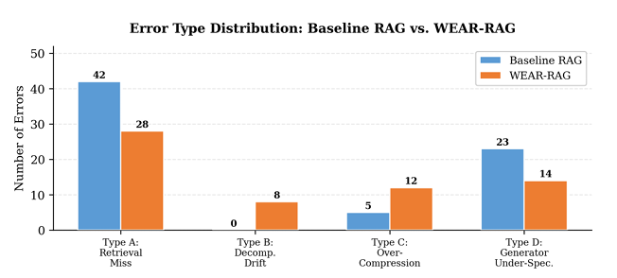

Fig. 10. Error type distribution. WEAR-RAG reduces retrieval misses (−33%) and generator errors (−39%), partially offset by new decomposition drift errors.

The equal-weight configuration underperforms, confirming that not all signals deserve equal treatment—the reranker provides a more valuable signal than the density heuristic. The similarity-heavy configuration de-grades the most, indicating that over-reliance on bi-encoder similarity without sufficient reranker weight loses the fine-grained relevance discrimination that drives answer quality.

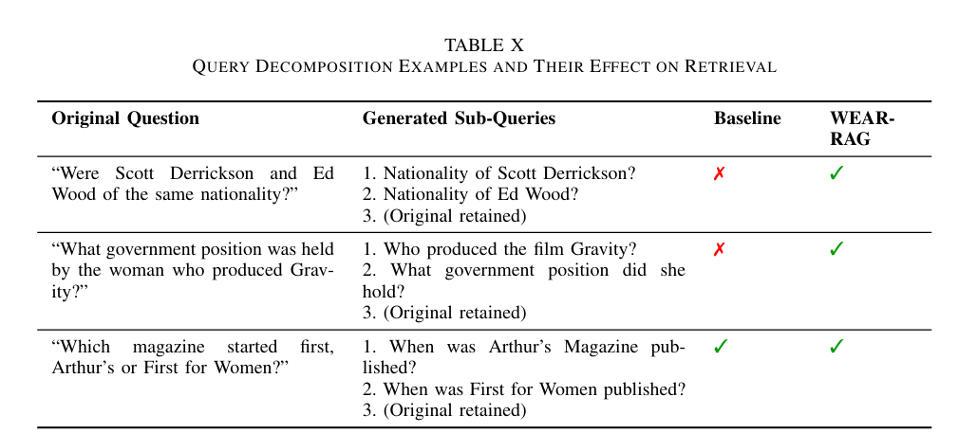

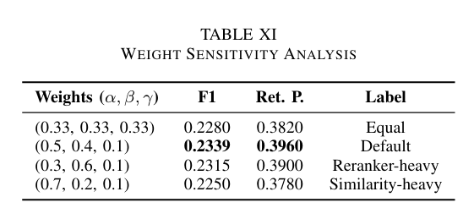

XI. VISUALIZATION AND INTERPRETABILITY
A key advantage of WEAR-RAG over prior systems is full evidence interpretability. Every evidence item carries decom-posed scores, enabling transparent debugging and auditability.

- Evidence Score Decomposition
Each selected evidence item includes:
- The raw similarity score Ssim from dense retrieval.
- The raw reranker score Srank from the cross-encoder.
- The density score Sdens from the content heuristic.
- The composite score S(c) and the weights used.
- The source document and chunk position.
- This decomposition allows practitioners to answer “Why was this chunk selected?” and “Why was that chunk filtered?” — capabilities absent in most RAG systems that only expose a single relevance score.

- Multi-Metric Radar
Fig. 11 provides a radar chart showing WEAR-RAG’s advantage across all six metrics simultaneously. The larger area covered by WEAR-RAG in the answer quality dimensions is visually apparent.

- Practical Debugging Workflow
WEAR-RAG supports a structured debugging workflow:
- Inspect generated sub-queries for decomposition drift.
- Examine reranked evidence items and their component scores.
- Compare retained vs. filtered chunks and their score mar-gins.
- Review the final prompt and generated answer.

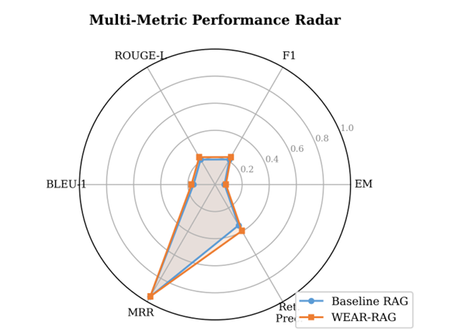

Fig. 11. Radar chart comparing all six metrics. WEAR-RAG (orange) covers a larger area in answer quality dimensions while overlapping with baseline in MRR.

This four-step process isolates errors to retrieval, decomposition, aggregation, or generation enabling targeted improvements.

XII. LIMITATIONS

We acknowledge the following limitations of WEAR-RAG:

- Heuristic Content Richness Score: The content richness metric uses simple proxies (length, type-token ratio, entity density) rather than learned content quality estimators. This limits its discriminative power for distinguishing genuinely informative chunks from superficially complex ones.
- Rule-Based Decomposition: The query decomposer relies on pattern matching for comparison, causal, and compound questions. It cannot handle arbitrary multi-hop reasoning chains or implicit decomposition requirements. LLM-based decomposition is available as an option but introduces additional latency and cost.
- No Hybrid Retrieval: WEAR-RAG uses purely dense re-trieval without incorporating sparse lexical signals (BM25). Hybrid retrieval could improve performance on keyword-specific queries where exact term matching is important.
- Fixed Aggregation Weights: The weights (α, β, γ) are manually set rather than learned from data. Optimal weights may vary across datasets, domains, and query types.
- Limited Evaluation Scale: Results are reported on 100 HotpotQA samples due to local compute constraints. Larger-scale evaluation with statistical significance testing would strengthen the conclusions.
- Cross-Encoder Latency: Reranking adds O(m × k) for-ward passes per query, which may be prohibitive for real-time applications with strict latency requirements.
- Statistical Validation: Statistical significance testing on larger datasets remains future work.
These limitations represent clear directions for future improvement and do not diminish the core contribution: demonstrating that weighted evidence aggregation is a viable and effective strategy for improving RAG quality.

XIII. CONCLUSION AND FUTURE WORK

- Summary
This paper presented WEAR-RAG, a modular retrieval-augmented generation pipeline that treats evidence curation as an explicit optimization target. Through four integrated innovations—semantic chunking, query decomposition, cross-encoder reranking, and weighted evidence aggregation—WEAR-RAG demonstrates consistent improvements over baseline RAG across six evaluation metrics on HotpotQA.
The core contribution, the multi-signal evidence scoring function S(c) = α · Ssim + β · Srank + γ · Srich, provides an interpretable, extensible framework for evidence quality assessment. The comparative evaluation confirms that each component contributes positively and synergistically.
- Key Takeaways
- Evidence curation matters: Explicit scoring and filtering yields measurable improvements over simple top-k selec-tion.
- Components are super-additive: The full pipeline outper-forms every partial system, and the combined gain exceeds the sum of individual contributions.
- Interpretability is achievable: Full score decomposition enables practical debugging without sacrificing perfor-mance.
- Context quality over model scale: Our results suggest that improving context quality is a more compute-efficient alternative to scaling model size for RAG systems.

- Future Work
1) Learned Weights: We can improve the weights by making them learnable. Of using fixed values for alpha, beta and gamma we can adjust them using a method that learns from feedback. This method can use gradients or reinforcement learning.
2) Adaptive Thresholding: We can adjust the threshold value, theta, based on how the question is or how confident we are in the retrieval results. The value of theta will depend on the query. This way we can make sure theta is suitable, for each question. The theta value will be based on the estimated difficulty of the question or how confident we're that the retrieval results are correct.
3) LLM Decomposition: Richer, context-aware sub-queries via LLM generation with self consistency verification.
4) Hybrid Retrieval: Combine dense and sparse (BM25) signals for robustness on keyword-heavy queries.
- Larger Evaluation: Full HotpotQA validation set + MuSiQue + 2WikiMultiHopQA with paired significance tests.
- Human Evaluation: Answer faithfulness, completeness, and readability judgments.
- End-to-End Aggregation Learning: An important future direction is end-to-end learning of the aggregation function, where evidence scoring is optimized jointly with genera-tion, enabling the system to adapt its evidence preferences to downstream task requirements.
More broadly, learning the aggregation function end-to- end—jointly optimizing retrieval, scoring, and generation—remains the most promising direction for advancing evidence-aware RAG systems.

REFERENCES

- Z. Ji, N. Lee, R. Frieske, T. Yu, D. Su, Y. Xu, E. Ishii, Y. Bang, Madotto, and P. Fung, “Survey of hallucination in natural language generation,” ACM Computing Surveys, vol. 55, no. 12, pp. 1–38, 2023.
- P. Lewis, E. Perez, A. Piktus, F. Petroni, V. Karpukhin, N. Goyal, H. K¨uttler, M. Lewis, W.-t. Yih, T. Rockt¨aschel, S. Riedel, and D. Kiela, “Retrieval-augmented generation for knowledge-intensive NLP tasks,” in Proc. NeurIPS, vol. 33, pp. 9459–9474, 2020.
- K. Guu, K. Lee, Z. Tung, P. Pasupat, and M.-W. Chang, “REALM: Retrieval-augmented language model pre-training,” in Proc. ICML, pp. 3929–3938, 2020.
- V. Karpukhin, B. Oguz, S. Min, P. Lewis, L. Wu, S. Edunov, D. Chen, and W.-t. Yih, “Dense passage retrieval for open-domain question answering,” in Proc. EMNLP, pp. 6769–6781, 2020.
- J. Johnson, M. Douze, and H. J´egou, “Billion-scale similarity search with GPUs,” IEEE Trans. Big Data, vol. 7, no. 3, pp. 535–547, 2021.
- R. Nogueira and K. Cho, “Passage re-ranking with BERT,” arXiv preprint arXiv:1901.04085, 2019.
- Z. Yang, P. Qi, S. Zhang, Y. Bengio, W. Cohen, R. Salakhutdinov, and Manning, “HotpotQA: A dataset for diverse, explainable multi-hop question answering,” in Proc. EMNLP, pp. 2369–2380, 2018.
- S. Min, V. Zhong, L. Zettlemoyer, and H. Hajishirzi, “Multi-hop reading comprehension through question decomposition and rescoring,” in Proc. ACL, pp. 6097–6109, 2019.
- G.Izacard and E. Grave, “Leveraging passage retrieval with generative models for open domain question answering,” in Proc. EACL, pp. 874–880, 2021.
- T. Gao, H. Yen, J. Yu, and D. Chen, “Enabling large language models to generate text with citations,” in Proc. EMNLP, pp. 6465–6488, 2023.
- Xu, Y. Shi, J. Yao, Y. Ren, D. Li, Y. Jia, and Q. Liu, “RECOMP: Improving retrieval-augmented LMs with compression and selective augmentation,” in Proc. ICLR, 2024.

